**22. Data Analytics for creditlimit.csv with visualization of graph**

**Aim :**

To write an R Program perform data analysis and visualization using a creditlimit.csv dataset

**Algorithm :**

**Step 1:** Start the process.

**Step 2:** Use setwd() to specify the folder where the dataset is stored.

**Step 3:** Use read.csv() to read Credit_train.csv into a dataframe called credit. **Step 4:** Use head(), summary(), and str() to check the structure and contents.Use colSums(is.na()) to find missing values.

**Step 5:** Draw histograms for numeric variables (BUSAGE, MAXLINEUTIL, TOTACBAL) to observe frequency distribution.

**Step 6:** Draw bar plots for categorical variables (BUSTYPE, DEFAULT) to view category frequencies.

**Step 7:** Create box plots for numeric variables to detect spread and outliers (BUSAGE, TOTACBAL, DAYSDELQ).

**Step 8:** Plot BUSAGE vs TOTACBAL and use colors to differentiate default (Y/N).

**Step 9:** Show the proportion of default vs non-default customers.

**Step 10:** Stop the program

**Program :**

setwd("C:/Users/MCA-007/Documents/R prog")

if (file.exists("Credit_train.csv")) {

credit <- read.csv("Credit_train.csv")

} else {

stop("File 'Credit_train.csv' not found in working directory!")

}

head(credit)

summary(credit)

str(credit)

colSums(is.na(credit))

hist(na.omit(credit$BUSAGE),

main="Histogram of BUSAGE",

xlab="BUSAGE", col="skyblue", border="black")

hist(na.omit(credit$MAXLINEUTIL),

main="Histogram of MAXLINEUTIL",

xlab="MAXLINEUTIL", col="orange", border="black")

hist(na.omit(credit$TOTACBAL),

main="Histogram of TOTACBAL",

xlab="TOTACBAL", col="green", border="black")

barplot(table(credit$BUSTYPE),

main="Bar Plot of BUSTYPE", col="blue")

barplot(table(credit$DEFAULT),

main="Bar Plot of DEFAULT", col=c("green","red"))

boxplot(na.omit(credit$BUSAGE), main="Boxplot of BUSAGE", col="lightgreen")

boxplot(na.omit(credit$TOTACBAL), main="Boxplot of TOTACBAL", col="lightpink")

boxplot(na.omit(credit$DAYSDELQ), main="Boxplot of DAYSDELQ", col="lightblue")

credit$DEFAULT <- as.factor(credit$DEFAULT)

plot(credit$BUSAGE, credit$TOTACBAL,

xlab="BUSAGE", ylab="TOTAL ACCOUNT BALANCE",

main="BUSAGE vs TOTACBAL",

col=ifelse(credit$DEFAULT=="Y","red","green"),

pch=19)

legend("topleft", legend=c("Default=Y","Default=N"),

col=c("red","green"), pch=19)

d <- as.data.frame(table(credit$DEFAULT))

pie(d$Freq, labels=paste(d$Var1, ":", d$Freq),

col=c("green","red"), main="Pie Chart of Default Status")

nums <- credit[, sapply(credit, is.numeric)]

cor_matrix <- cor(nums, use="complete.obs")

**OUTPUT:**

**Bar Plot**

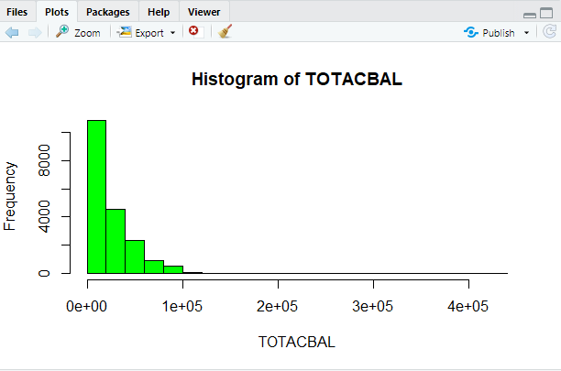

**Box Plot**

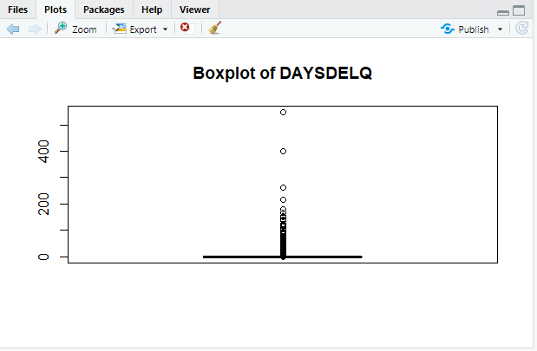

**Scatter Plot**

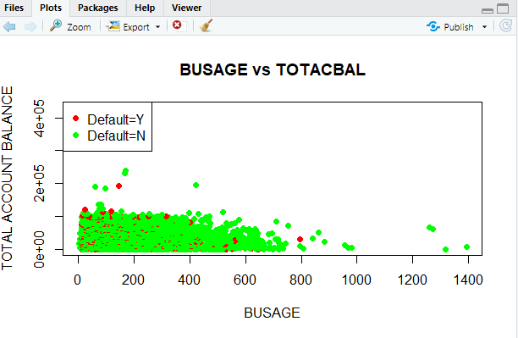

**Pie Chart**

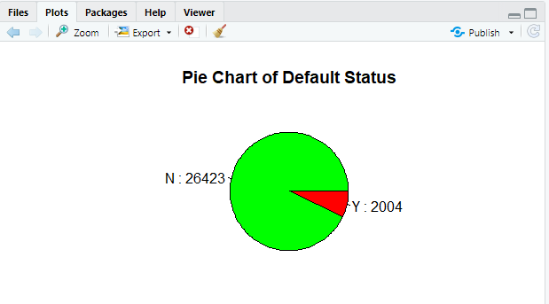

**RESULT:**

Thus, our program has been successfully saved and executed.